If you have ever had the privilege of attending a Microeconomics 101 class, you probably remember consumers always face a budget constraint. When making any economic decision, we need to optimize our choices since we only have a limited amount of income or wealth to spend. If you have not taken any micro lessons, no worries! You made the right choice and will understand the rest of the article without problem.
Budgets are most commonly expressed in monetary terms, but any other unit works to denote the idea that action is constrained by a finite amount of such a good. In fact, carbon budgets have been a central tool of European climate action to achieve carbon neutrality by 2050.

The Theory
A surprising but well-established finding in climate science is that there is a near linear relationship between cumulative anthropogenic CO₂ emissions and global mean temperature increases –– this is known as the Transient Climate Response to Cumulative CO₂ Emissions (TCRE).
In particular, it is estimated that every 1,000 GtCO₂ is associated with a 0.45 ºC temperature increase, enabling back-of-the-envelope calculations to infer a carbon budget for a specific temperature rise target in global terms. The relation can be expressed as follows — given that we have already observed significant warming above pre-industrial levels, we must subtract this from the temperature target to calculate the remaining carbon budget:
$$Carbon Budget = \frac{{ΔT}_{target} - {ΔT}_{observed}}{σ_{TCRE}}$$
- $ΔT_{target}$ represents the temperature increase limit (relative to pre-industrial levels).
- $ΔT_{observed}$ is the temperature increase already observed.
- $σ_{TCRE}$ is the TCRE constant (0.45 ºC per 1,000 GtCO₂, where “GtCO₂” stands for gigatonnes of carbon dioxide, which is equivalent to a billion tons or 10⁹ tons).
A carbon budget can thus be defined as the total cumulative amount of CO₂ that can be emitted while keeping global warming below a specific temperature limit (for example, 1.5°C or 2°C above pre-industrial levels, following the recommended thresholds for avoiding irreversible damages according to the Paris Agreement).
Based on current estimates, global mean temperature has already increased by about 1.41 °C relative to pre-industrial levels. Under central estimates of the TCRE, this implies remaining global carbon budgets of approximately 200 GtCO₂ for the 1.5°C target and 1,311 GtCO₂ for the 2°C target.
$${CB}_{1.5 ºC} = \frac{1.5 ºC - 1.41 ºC}{\frac{0.45 ºC}{1000 {GtCO}_{2}}} = 200 {GtCO}_{2}$$
$${CB}_{2 ºC} = \frac{2 ºC - 1.41 ºC}{\frac{0.45 ºC}{1000 {GtCO}_{2}}} = 1311 {GtCO}_{2}$$
Put another way, at current rates of emissions, we will exhaust the carbon budgets associated with the Paris Agreement targets of 1.5°C or 2°C of warming within roughly 4.5 and 30.5 years, respectively.
Notice that this implies that there is a carbon budget for every climate goal. The more we want to limit additional temperature increases, the tighter the carbon budget. On the other hand, some people such as the current tenant of the White House, who do not care at all about climate change, or even believe it is not happening, would (rationally) advocate for an unlimited carbon budget. It only makes sense to discuss carbon budgets if we consider it important to limit emissions.
An important reminder is that carbon is a stock pollutant. About half of today's emissions dissipate relatively quickly (they are absorbed by land and ocean carbon sinks), but the remaining fifty percent will take centuries to millennia to do so. Therefore, we must think of carbon budgets as the total amount of carbon we can emit ad aeternum – not this year or this decade, but forever.
As long as we keep emitting, temperature will continue to rise, so any reasonable carbon budget requires reaching net-zero emissions at some point in time. Since it is virtually impossible to cut all emissions, net zero (or carbon neutrality) means that the residual emissions are offset by carbon sinks such as forests and oceans, or even carbon capture technologies in the future. In this respect, many developed countries, including the European Union, have chosen 2050 as the milestone year to reach carbon neutrality.

A Cost-Effectiveness Approach
Setting the constraint is quite straightforward. Setting the agenda to achieve it is not. There are many options to cut emissions, but since climate action competes with other societal priorities, policymakers should ideally enact the most cost-effective policies first. For this purpose, we use the concept of abatement cost, the cost of reducing one ton of CO₂ relative to a baseline.
$$Abatement Cost = \frac{cost with policy - cost without policy}{emissions without policy - emissions with policy}$$
In theory, the idea is simple. First, calculate the abatement cost for each climate policy and order them in ascending cost, as shown in Figure 1. Popularized by McKinsey & Company in a 2007 report, this is called the Marginal Abatement Cost curve, where the width of the bars correspond to the abatement potential (tons of carbon dioxide). Second, enough policies should be enacted to ensure total abated carbon keeps us within the carbon budget (A* in the figure) –– together, these form the optimal policy portfolio.

Figure 1. Illustration of the optimal policy portfolio
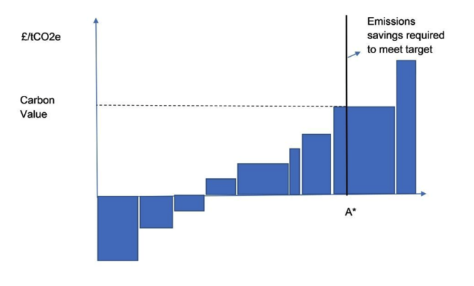
Source: UK Regulatory Policy Committee.
In practice, this is a complex exercise, meaning marginal abatement cost curves should be interpreted as support for policy making rather than precise rankings. For example, policies are not enacted at the same time or speed and modeling assumptions must be made about the future evolution of innovation and demand, introducing uncertainty to the estimates. Moreover, intertemporal choices must be made. Should we consume the larger share of the budget today and drastically cut emissions in the future, or follow a more gradual trajectory? Different scenarios, such as the ones drafted by the IPCC (the so-called "Shared Socioeconomic Pathways", or "SSP" for short), imply different emission reduction timelines. At the national level, countries that have enacted carbon budgets typically design sector-specific emissions reduction pathways.
Nevertheless, this effort is worthwhile as it provides valuable insights. Once the optimal policy portfolio is defined, we can determine the abatement cost of the marginal policy and use it as a benchmark to evaluate investments and public policies. This benchmark is commonly known as the shadow price (or shadow cost) of carbon, a name that reflects its nature as an implicit valuation rather than a market-based price (such as those in cap-and-trade systems or carbon taxes).
Any climate policy with an abatement cost lower than the shadow price is, in principle, worth pursuing. However, policy choices must follow a long-term perspective to avoid situations where actions designed to achieve immediate CO₂ reductions lock in inefficient technologies and crowd out more structural long-term solutions.

How Much Should We Value Climate Action?
France provides a particularly instructive case study for this approach. As a pioneer in implementing this methodological framework, France has commissioned up to four expert panels tasked with computing and updating the shadow price of carbon. In France this is known as the value for climate action (VCA)
Table 1 shows how the estimates have evolved across the different commission reports. The rising value for climate action reflects two distinct mechanisms. First, an intertemporal effect, akin to the Hotelling rule applied to a scarce carbon budget, requires the carbon value to increase over time to ensure dynamic consistency — that is, to maintain equivalent present values across periods and avoid creating artificial incentives to shift abatement efforts intertemporally. Second, as low-cost abatement options are implemented first, marginal abatement costs rise, further pushing the value for climate action upward.

Table 1. Evolution of estimates for the Value of Climate Action
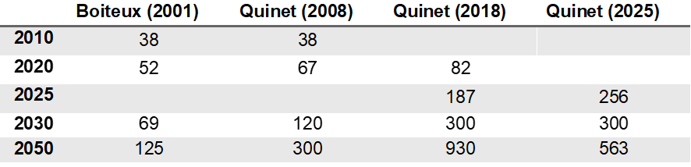Note: Column names refer to commission chair and year. Figures are in 2023 euros assuming 20% cumulative inflation between 2018 and 2023. The downward revision of the 2050 carbon value estimate in the latest edition resulted mainly from two factors: a reduction in the risk-free public discount rate from 4.5% to 3.2%, and a greater concentration of emission reductions in the 2020s and 2030s relative to the 2040s. Sources: Quinet Report 2008, Quinet Report 2019, Quinet Report 2025.
The UK’s Regulatory Policy Committee has followed a similar methodology computing their marginal abatement cost curves and obtaining the shadow prices of €₂₀₂₃315 for 2030 and €₂₀₂₃460 for 2050. Nevertheless, they advise considering a ±50% sensitivity range reflecting “genuine uncertainty about future technology costs and their evolution.”

Comparison With the Social Cost of Carbon
There is another benchmark to calculate how much society should value emissions: the social cost of carbon (SCC). Like the VCA, it represents a shadow price for carbon that informs policymakers whether a policy is worthwhile based on its efficiency in cutting emissions. However, it stems from a very different methodology. The VCA follows a normative cost-effectiveness approach — assuming an optimal temperature limit a priori and deriving the carbon budget from that target. The SCC, by contrast, uses a cost-benefit framework built on Integrated Assessment Models, treating emissions as a negative externality problem. See our article The Social Cost of Carbon, and Why It Is No Longer Counted, for further explanation.
In short, emitting CO₂ entails damages to society that are not borne by the emitter. If emissions were priced appropriately to internalize this externality, the market would emit far less carbon. Yet, pricing emissions is where this methodology becomes particularly challenging. Determining which damages to include (mortality, morbidity, productivity losses, forced migration...) and measuring the exact margin by which climate change exacerbates them is subject to considerable uncertainty. In fact, for some cold regions, climate change might even constitute a positive externality!
In practice, these competing methodologies have shaped distinct policy frameworks. The European Union and the United Kingdom have adopted carbon budgets as the primary basis for setting long-term climate targets, while the US has followed the SCC approach… at least until Trump’s second Administration.

How Carbon Budgets Work in the Real World
The original motivation for this article was to clarify what the carbon budget recently enacted by the Catalan Government entails. Nonetheless, despite their claims of being a "global pioneer," it was the United Kingdom the first to adopt carbon budgets through the Climate Change Act (2008) — a framework that was already presented to the Catalan Parliament by a UK consultancy as early as January 2009.
The Climate Change Act established the Climate Change Committee (CCC), an independent body that provides evidence-based advice on legally mandated carbon budgets, while the Government remains responsible for policy implementation. Five-year carbon budgets are proposed in advance and must align with the Net Zero 2050 target (the seventh, covering 2038-2042, was proposed in 2025). The CCC develops a "balanced pathway" by assessing credible emission reductions across economic sectors through cost-effectiveness analysis. Note that this framework incorporates all the elements discussed above: a normative Net Zero 2050 goal, sectoral cost-effectiveness assessment of abatement costs, and the resulting optimal pathway recommendations, tailored to sector-specific limitations and opportunities.
As shown in Figure 2, the UK met its first three carbon budgets, nearly halving emissions since 1990. However, progress has relied heavily on energy sector transformations: coal phase-out and renewable electricity expansion. The CCC warns that emission reductions in other sectors must accelerate to meet future targets once these low-cost options are exhausted.

Figure 2. UK CO₂ emissions and carbon budgets
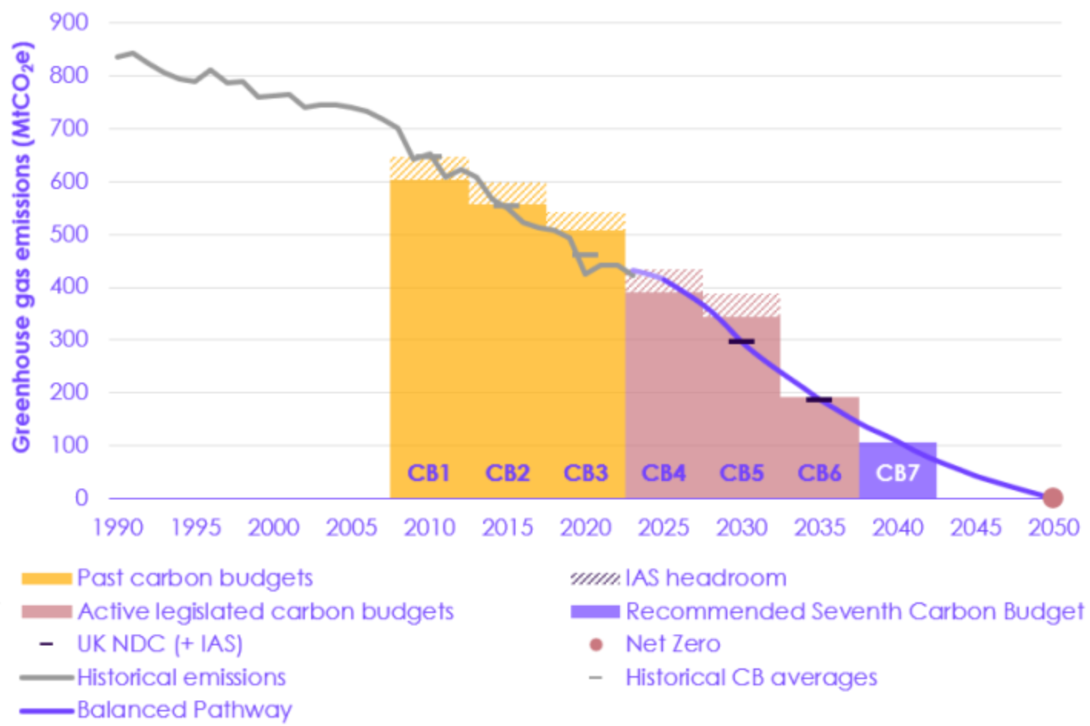
Note: Greenhouse gas emissions are capped over five-year periods; the first carbon budget (CB1) was set at 3,018 MtCO₂-eq, equivalent to an average of about 600 MtCO₂-eq per year. “IAS” stands for International Aviation and Shipping, a sector excluded from the first five carbon budgets.“UK NDC” refers to the UK’s Nationally Determined Contributions. Source: UK Seventh Carbon Budget.

Mixed Results Among Followers
While many countries have enacted climate legislation defining emission reduction targets and carbon pricing mechanisms, legally binding carbon budgets remain relatively rare. Beyond the UK and the EU, countries that have adopted this framework include France (2015), New Zealand (2019), and Ireland (2021), with mixed results:
- France exceeded its first carbon budget (2015-2018) by 61 MtCO₂-eq but met the second (2019-2023) with a margin of 91 MtCO₂-eq, compensating for the initial shortfall, according to governmental monitoring.
- New Zealand is on track to achieve its first emissions budget (2022–2025), though meeting the second (2026–2030) and third (2031–2035) will require more ambitious policies, according to the 2025 monitoring report.
- Ireland is projected to exceed both its first (2021–2025) and second (2026–2030) carbon budgets by a cumulative 77 to 114 MtCO₂-eq, according to the Irish Environmental Protection Agency.
Note, however, that for EU countries, climate ambition is set in Brussels, currently targeting a 55% reduction by 2030 relative to 1990 levels and Net Zero by 2050. While these targets imply an aggregate carbon budget, the EU has not formalized explicit carbon budgets in absolute terms (GtCO₂). For sectors covered by the EU Emissions Trading System (ETS), emissions are governed by declining caps. For non-ETS sectors, member states receive binding national emission reduction targets (allocated based on GDP per capita), but retain flexibility in translating them into national plans and sectoral policies, which can include carbon budgets. As the cases of France and Ireland illustrate, countries may fall short of their national carbon budgets without facing EU-level sanctions, provided they remain on track with their binding EU emission targets.
What room remains, then, for regional initiatives like Catalonia's carbon budget? In principle, limited room, as it must comply with national and European guidelines. However, regional governments can increase ambition beyond these baselines and tailor sectoral pathways to local realities — precisely the stated purpose of Catalonia's proposal.

The Elephant in the Room: International Cooperation
Emissions don't know borders, but states hold legislative power, so carbon budgets are most frequently set at the national level. This raises two problems: first, how do we split the effort needed to limit global warming below a given threshold? Second, how do we hold all countries or regions accountable to comply with their shares?
Even assuming the Paris Agreement 2°C consensus holds — that is, all countries indirectly agree on a global carbon budget of around 1,300 GtCO₂ as computed above — how should it be allocated across nations? Proportional to population shares? Based on historical emission records?
The two criteria pull in very different directions: a population-proportional budget is blind to historical responsibility, while applying a strictly historical-responsibility framework poses its own problem. If we were to allocate population-proportional budgets over the entire period since 1850, developed countries would have already far exceeded their shares, meaning that, under this logic, they would need to reach net zero immediately, which is, of course, completely infeasible.
The EU and other developed countries have partially sidestepped this question by committing to climate neutrality by the middle of the century. However, even the pathways to Net Zero still imply consumption of the global carbon budget up until 2050.
To keep things grounded, let us run some numbers again. The UK is home to 0.84% of the world's population, so a population-proportional carbon budget would grant it 0.84% of the remaining global carbon budget of 1,311 GtCO₂-eq — roughly 11 GtCO₂-eq, or 11,012 MtCO₂-eq. Adding the remaining two years of the fourth carbon budget (780 MtCO₂-eq) to the fifth and sixth carbon budgets (1,750 and 965 MtCO₂-eq, respectively), and assuming Parliament sanctions the CCC's recommendation for the seventh (535 MtCO₂-eq), by 2042 the UK will have emitted around 4,030 MtCO₂-eq. Therefore, if the UK manages to comply with its Net Zero pledges, this would comfortably place the country within 50% of its population-proportional carbon budget.
On the other hand, reconstructing the UK's historical contribution is a harder exercise, as we should not only account for all emissions since 1850, but also for the changes in the UK’s share of world population. A stylised calculation suggests that the UK represented 1.51% of the world’s population when aggregated across all years from 1850 to 2023, while accounting for 2.85% of cumulative global emissions over the same period. That is, it has already emitted almost twice as much as it would be entitled following this simplified historical-responsibility framework. This shows that even relatively progressive but developed countries have already exhausted any “fair share” of the global carbon budget under strict historical accounting.

Why Europe Cannot Solve Climate Change Alone
The second problem is even more troublesome. The near-linear relationship between cumulative carbon emissions and temperature rise described by the TCRE holds in global terms, so even if Europe reaches climate neutrality by mid-century, these reductions might be offset by increased emissions elsewhere. In fact, despite Europe having cut emissions by 36% relative to 1990 levels by 2024, global emissions have risen 45% over the same period, a gap that is even starker in absolute terms.
These reductions are not meaningless: had Europe continued emitting at 1990 levels, we would overshoot 2°C by a larger margin. But in isolation, it is powerless to meet Paris Agreement goals alone.
From a game theory perspective, it is irrational for nations to unilaterally reduce emissions unless they internalize a shadow cost of carbon — which renders all policies below that threshold inherently beneficial — or credible sanctions exist for non-cooperating countries. Unfortunately, very few countries seriously incorporate the former into their legislative frameworks (the recent dismissal of the SCC by the second Trump administration being the most concerning example), and the latter remains highly unlikely in the near future.
One notable exception is the EU's Carbon Border Adjustment Mechanism (CBAM), which attempts to address this coordination failure by imposing costs on carbon-intensive imports from non-cooperating countries — effectively creating economic incentives for trading partners to adopt climate policies. Look out for our forthcoming article analyzing CBAM's mechanisms and effectiveness.

Takeaways
Climate policies are often costly and compete with other societal priorities, so governments need a strong motivation to enact them. Scientific consensus points to larger damages from climate change if we fail to act urgently. According to the second Quinet Report, without specific efforts to reduce emissions, the global carbon budget to keep warming below 2°C would be spent by mid-century, an estimate consistent with the back-of-the-envelope calculations presented earlier in this article.
The approach presented here differs from other methodologies in that it first assumes a temperature ceiling and consequently derives the corresponding carbon budget, which determines the shadow cost of carbon given certain assumptions regarding innovation and demand growth. Each step introduces additional uncertainty, though this is expected in any exercise projecting decades into the future — the same applies when estimating the social cost of carbon or the world’s population 50 years from now.
Nonetheless, the exercise yields several solid conclusions. First, the VCA is clearly not zero, and a significant increase in climate action is needed to stay within the global carbon budget. For those who want to explore further and play with the uncertainty ranges, I recommend the Carbon Budget Explorer, created by the Netherlands eScience Center and the Netherlands Environmental Assessment Agency.
Second, the UK's and EU ETS successes demonstrate that carbon budgets can work when supported by consistent policy and political commitment. Other countries, however, show that legislation alone is insufficient without robust implementation.
Last but not least, unless international cooperation improves, regional efforts risk becoming futile — perhaps the most sobering conclusion given current events. Amid the US retreat from most international organizations, regional initiatives like Catalonia's gain renewed significance, more than we initially gave them credit for.
Carbon budgets do not solve climate change on their own. But they translate abstract temperature goals into emissions constraints, expose trade-offs transparently, and discipline policymaking over time. In a world where international cooperation remains fragile, that discipline may be one of the most valuable climate policy tools we have.

The likely confidence interval for the TCRE is [0.27, 0.63] (IPCC AR6, Longer report, p. 82); in IPCC terminology, “likely” corresponds to anything between 66 to 100% probability. This relationship therefore holds at the global level and abstracts from non-CO₂ forcing and uncertainty ranges.
The TCRE relationship applies to CO₂ emissions, whereas most carbon budgets in practice are defined in CO₂-equivalent terms, where other greenhouse gases such as methane, nitrous oxide, and fluorinated gases are converted to CO₂ equivalents based on their warming potential and atmospheric lifetime. This approach is appropriate for short- to mid-term carbon budgets, but for longer-term budgets it is more accurate to express them in CO₂ terms only. This is because CO₂ remains in the atmosphere for centuries, while other greenhouse gases are mostly short-lived and removed relatively quickly from the atmosphere, meaning the timing of their emissions becomes significant.
In our article The Orinoco Belt Tightens we used similar calculations to explore the climate consequences of a revived Venezuelan oil sector.
In 2023 and 2024, global CO₂ emissions were around 43 Gt.
According to the IPCC AR6, “land and ocean sinks have taken up a near-constant proportion (globally about 56% per year) of CO₂ emissions from human activities over the past six decades, with regional differences (high confidence)” (longer report, p. 42).
In economic jargon, the shadow price of carbon corresponds to the Lagrange multiplier (λ) on the cumulative carbon budget constraint in an intertemporal welfare-maximization problem. It represents the marginal increase in social welfare from relaxing the constraint by one tonne, or equivalently, the opportunity cost of emitting an additional tonne of CO₂ under a binding budget.
I have assumed a conversion factor from £₂₀₂₂ to €₂₀₂₃ of 1.15.
The calculation is just for illustrative purposes, using historical population and GHG emissions data from Our World in Data. A Carbon Brief article reveals that the UK share of global emissions increases from 3.0% to 5.1% when including its colonial rule, though this would also increase their historical population share.

